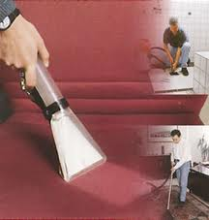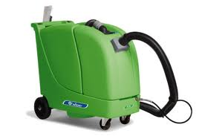Logo_UPHOLSTERYLogo_FOOD

Laundry

###### CHEMICAL CLEANING PRODUCTS

**ZAK-DELICAT**

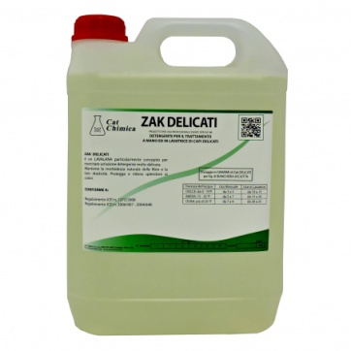It is a wool cleaner designed to give a delicate cleaning action.

**Packaging**:

* **Can:** 5 Kg, 10 Kg , 25 Kg

**Type:** Neutral

**Ideal for:** Textiles, Laundry

|  |
| --- |
|  |

**ZAK-FORTE**

Liquid cleaner for washing machine. May be used on cotton, synthetic. A complete and rich product. To be used with electronic dispenser.

**Packaging**:

* **Can:** 10 Kg, 25 Kg

**Type:** Alkaline

**Ideal for:** Textiles, Laundry

**ZAK-L**

Liquid cleaner for washing machine. To be used with electronic dispenser. May be used on cotton, synthetic, natural. A complete and rich product.

**Packaging**:

* **Can:** 10 Kg, 25 Kg

**Type:** Neutral

**Ideal for:** Textiles, Laundry

|  |
| --- |
|  |

**ZAK-OXI**

Bleach oxygene to inject in beaching phase. Used in automatic machine by a special dispenser. Active on stains, eliminates and prevents turning yellow, eliminates bacteria's that cause bad odours.

**Packaging**:

**Can:** 5Kg, 10Kg, 25Kg

**Type:** Alkaline

**Ideal for:** Textiles, Laundry

|  |
| --- |
|  |

**ZAK-PLUS**

Reinforcing cleaner very concentrated and effective on stains. Increases cleaner power when its very dirty. Can be used on coloured textiles, working clothes, tablecloths.

**Packaging**:

* **Can:** 10 Kg, 25 Kg

**Type:** Neutral   
**Ideal for:** Textiles, Laundry

|  |
| --- |
|  |

**ZAK-POLVERE**

Powder cleaner for washing machines. May be used on any kind of textiles, white, colour, cotton, hemp, synthetic.

[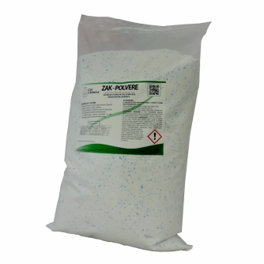](http://www.catchimica.com/dati/prodotti/imgprodotto_201702024642_zackpolv.jpg)A complete and rich product.

**Packaging**:

* Bags of 20 Kg

**Type:** Neutral

**Ideal for:** Textiles, Laundry

|  |
| --- |
|  |

**ZAK-SOFT**

Conditioner for washing machines. Its main function is to leave textiles softer and easier for ironing. It also, has an antistatic effect on textiles.

**[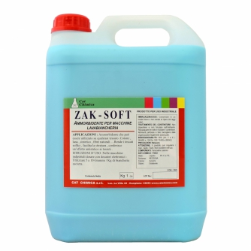](http://www.catchimica.com/dati/prodotti/imgprodotto_201610265210_zacksoft.jpg)**

**Packaging**:

* **Can:** 10 Kg, 25 Kg

**Type:** Neutral

**Ideal for:** Textiles, Laundry

|  |
| --- |
|  |

**ZAK- CL**

ZAK - CL is a chlorine bleach to inject in the bleaching phase. Used in automatic washing machine by a special dispenser.

**Packaging**:

* **Can:** 5Kg, 10Kg, 25Kg

**Type:** Alkaline

**Ideal for:** Textiles, Laundry